1. Install ganache-cli <https://github.com/trufflesuite/ganache/releases>

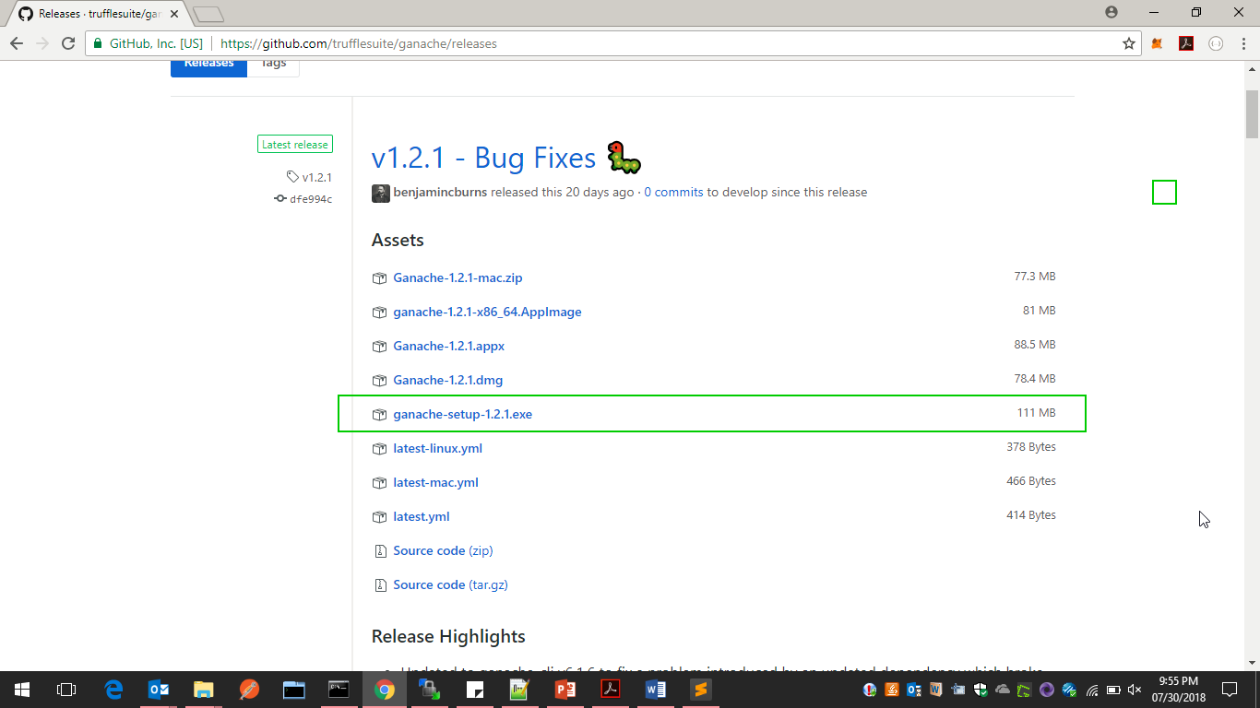

1. Install node <https://nodejs.org/en/download/>

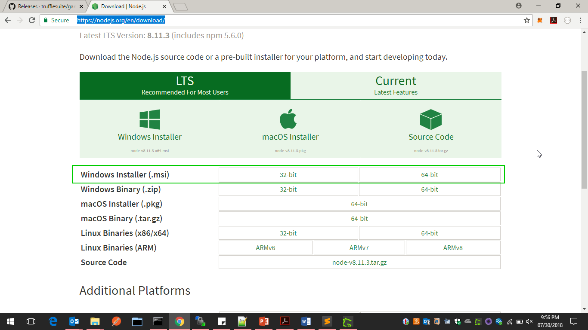

1. npm install -g truffle
2. goto folder C:\Users\XXXX\AppData\Roaming\npm , rename truffle.cmd to truff.cmd
3. mkdir greeter //make a project directory
4. cd greeter
5. truffle init //initialize a new truffle project
6. We will start by writing our smart contract called **greeter.sol**, then we will compile and interact with it by using truffle console
7. Inside contracts directory create a new file called greeter.sol with the following code:
8. pragma solidity ^0.4.17;
9. *// We have to specify what version of compiler this code will compile with*
10. contract mortal {
11. /* Define variable owner of the type address*/
12. address owner;
13. /* this function is executed at initialization and sets the owner of the contract */
14. function mortal() { owner = msg.sender; }
15. /* Function to recover the funds on the contract */
16. function kill() { if (msg.sender == owner) selfdestruct(owner); }
17. }
18. contract greeter is mortal {
19. /* define variable greeting of the type string */
20. string greeting;
21. /* this runs when the contract is executed */
22. function greeter(string _greeting) public {
23. greeting = _greeting;
24. }
26. function setGreeting(string _greeting) public {
27. greeting = _greeting;
28. }

31. /* main function */
32. function greet() constant returns (string) {
33. return greeting;
34. }
36. }
38. To deploy our newly created contract we need to add a file 2_deploy_contract.js file under migrations folder. After creating this file add the following code to it

var greeter = artifacts.require("./greeter.sol");

module.exports = function(deployer) {

deployer.deploy(greeter,'Hi Hello' , {gas: 6700000});

};

1. Inside our backend directory, open up **truffle.js** and add the following code:

module.exports = {

networks:{

development:{

host:"localhost",

port:7545,

network_id:'*'

}

}

};

1. Inside rating folder, type truffle compile

truff compile

This will create a new folder called build. This build folder contains JSON objects that will be used to deploy our smart contracts. Finally run truffle migrate

truff migrate

As we are connected and running our testrpc on the same port we will see our smart contracts deployed successfully. Now that we have deployed our contract we can interact with it within the truffle console

truff console

Lets see where the contract was deployed:

**greeter.address**

We will get the address where the contract was deployed in the network.

Truffle console commands

greeter.at(greeter.address).greet()

greeter.at(greeter.address). setGreeting ('Change Greet value')

greeter.at(greeter.address).greet()